AVI in Status Bar
Please read the credits for this code
Written by: Pete Sral

Monday, February 07, 2000
Version 1.0.0

This program show an easy way to put an AVI in the status bar.

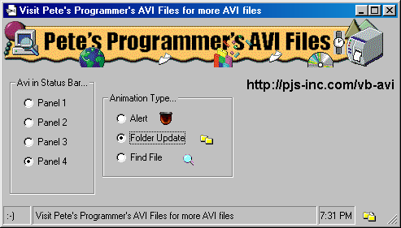

Credits
The idea for this code was inspired by James E. Toebes’ code:
Progress Meter on Status Bar | VB 5.0/6.0 | James E. Toebes
Ever wanted to put a progress meter on the status bar? Didn't want to mess with API or custom controls? Here's a simple trick to do just that.

To get more avi’s for you apps… go to http://pjs-inc.com/vb-avi

